

MILSTONE 3 :API logic Integration
In Milestone 3, the focus shifts to designing and integrating the backend API logic that
powers document generation using the Gemini 1.5 Pro model. This milestone ensures a
functional bridge between frontend inputs and the AI-powered document generation,
which is the core of the LegalEase project.

Activity 3.1: Create and configure main.py
Steps :
→ Initialize the FastAPI app
→ Define a root (/) endpoint to verify the service is running
→ Include routes from the routes.py module
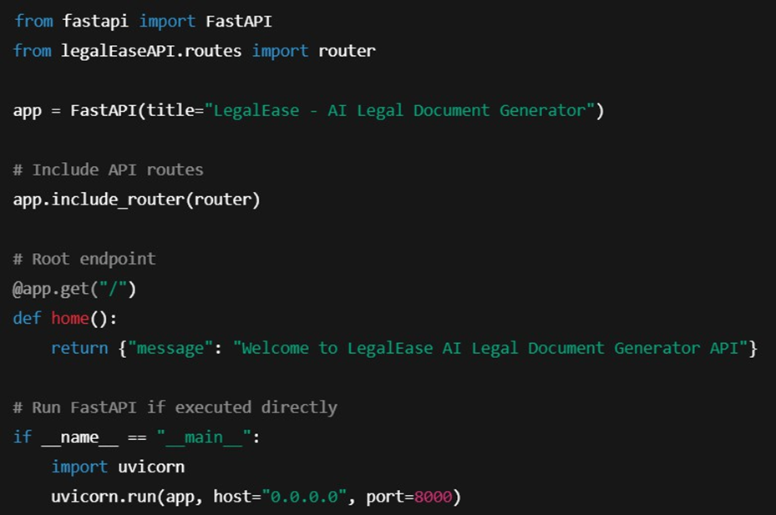

Activity 3.2: Handle Document Generation Logic in routes.py
This task handles user inputs from the frontend and sends them to the Gemini model for document generation.
Steps:
→ Define a Pydantic DocumentRequest model to validate incoming data.
→ Initialize the GeminiDocumentGenerator from ai_core.gemini_generator.
→ Create a POST endpoint (/generate) to accept user input and return generated legal content.
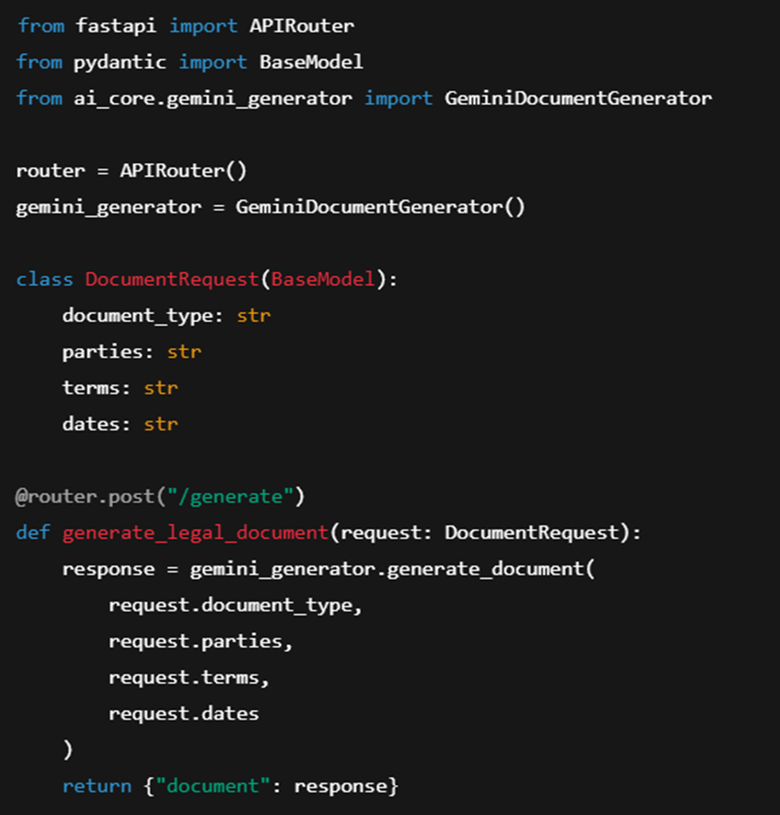

MILSTONE 4 : Frontend Development – LegalEaseMilestone 4 focuses on creating a responsive and user-centric web interface for
LegalEase using Streamlit. This milestone enables users to easily input legal details,
generate AI-powered documents, preview the results, make inline edits, and download
documents in multiple formats (TXT, DOCX, PDF) with rich formatting and embedded branding.

Activity 4.1 : Designing and Developing the User Interface
Step 1: Streamlit Page Configuration and Layout Setup
→ Configured Streamlit app with:
→ Added a three-column layout using st.columns to center-align the company logo
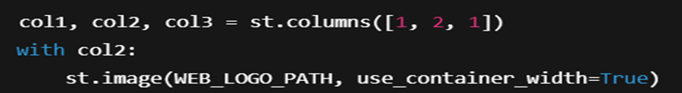
Step 2 : Header and Title
Displayed a subtle center-aligned title under the logo:
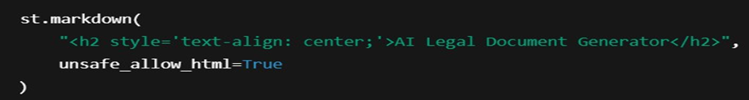
Step 3 : User Inptu Interface
Created intuitive inputs for:
- document_type: type of legal document
- parties: involved stakeholders
- terms: semicolon-separated clauses
- Dates: effective date

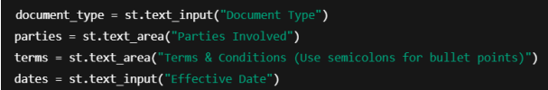
Activity 4.1 : Creating Dynamic Previews and Exports Options
Step 1: Generate Document with Backend AI
→ On clicking "Generate Document", a POST request is sent to the FastAPI backend
AI-generated content is sanitized and displayed dynamically:
Step 2: HTML Preview Rendering
The output is previewed in an elegant dark-themed scrollable card with semantic HTML:
Step 3: Editable Document Preview
The user can click "Edit Document" and modify the generated content using a text area:
Step 4: Multi-Format Download Options
Users can download the document as:
→ .txt (Plain Text)
→ .docx (Formatted Word Document with logo, headings, and table)
→ .pdf (Branded PDF with logo and footer)

Core Functions & Utilities
Sanitize_text(text)
→ Removes special characters and typographic quotes to ensure clean formatting.
Format_docx(text, doc_type)
● Uses python-docx to:
→ Embed logo
→ Add titles, paragraph formatting
→ Auto-generate a Terms table from semicolon-separated input
Format_pdf(text, doc_type)
● Utilizes FPDF with custom header/footer:
→ Center-aligned logo
→ Bold headings for sections
→ Bullet-style terms
Format_html_preview(text)
● Converts output to stylized HTML blocks for inline display.

